Design Document: Memory Management Simulator
Project: Memory Management Simulator
Date: January 2026

Table of Contents
- Executive Summary
- System Architecture
- Memory Layout and Assumptions
- Component Design
- Allocation Strategy Implementations
- Buddy System Design
- Multilevel Cache Simulation
- Data Structures
- Algorithm Specifications
- System Flow and Interactions
- Limitations and Simplifications
- Performance Analysis

Executive Summary
The Memory Management Simulator is a user-space OS-level simulation that models fundamental memory management operations. The system provides:
- Physical Memory Management: Configurable memory pool with dynamic block allocation/deallocation
- Multiple Allocation Strategies: First Fit, Best Fit, Worst Fit, and Buddy allocation
- Multilevel Cache Simulation: L1 and L2 cache hierarchy with LRU replacement policy
- Comprehensive Statistics: Fragmentation metrics, hit ratios, and utilization tracking
This document details the internal design, data structures, algorithms, and implementation choices.

System Architecture
High-Level Architecture Diagram
The simulator is organized into distinct, modular components that work together seamlessly:
- CLI Interface: User command parsing and interaction
- Allocator Manager: Coordinates allocation strategy operations
- Cache System Manager: Manages L1 and L2 cache hierarchy
- Allocation Core: Implements specific allocation algorithms
- Physical Memory Block Manager: Maintains memory block linked list
- Statistics & Reporting Module: Calculates and displays metrics

Memory Layout and Assumptions
Physical Memory Model
The simulator models a byte-addressable physical memory space with dynamic block allocation:
- Start Address: Beginning of memory pool
- Size: Configurable in bytes
- Allocation Status: USED or FREE
- Block ID: Unique identifier for tracking
- Metadata: Owner information and status
Key Assumptions
- Byte-Addressable Memory: All addresses and sizes expressed in bytes
- Contiguous Allocation: All allocated blocks are contiguous
- Single Process: Simulator runs in single-threaded mode
- No Virtual Memory: All addresses are physical addresses
- Fixed Block Size: Cache lines use fixed block size across all levels
- LRU Cache Policy: LRU replacement used (LFU not implemented)
Memory Initialization
The memory system initializes with a single FREE block spanning the entire requested size. This block is then split and managed according to the selected allocation strategy.

Component Design
1. Memory Manager Component
Responsibility: Maintain physical memory state and coordinate operations
Key Methods:
- Init size: Creates single FREE block spanning entire memory
- malloc size: Delegates to strategy-specific allocator
- free block_id: Marks block FREE, triggers coalescing
- coalesce(): Merges adjacent FREE blocks
- find_block(block_id): Locates block by identifier
- dump: Visualizes current memory layout
- stats: Calculates and returns statistics
2. Allocator Strategy Component
Responsibility: Implement specific allocation algorithms
Each strategy implements the core allocation interface and provides its own optimization approach:
- First Fit: Fast allocation, moderate fragmentation
- Best Fit: Optimized utilization, slower allocation
- Worst Fit: Preserves large free blocks, variable fragmentation
- Buddy: O(log n) operations, power-of-two constraint
3. Cache Component
Responsibility: Simulate multilevel cache hierarchy
The cache system models realistic CPU cache behavior:
- L1 Cache: Small, fast, closest to CPU
- L2 Cache: Larger, slower, miss victim handling
- LRU Replacement: Evicts least recently used entries on miss
- Statistics: Tracks hits, misses, and ratios per level

Allocation Strategy Implementations
First Fit Algorithm
Approach: Allocate from first available block large enough
Characteristics:
- Best for: Quick allocations, low-latency systems
- Fragmentation: Moderate external fragmentation
- Time Complexity: O(n) average case
- Space Complexity: O(n) for block metadata
Advantages:
- Fast allocation
- Simple implementation
- Good for small allocations
Disadvantages:
- Leaves gaps scattered throughout memory
- Inefficient memory utilization
- Fragmentation increases over time
Best Fit Algorithm
Approach: Find smallest block that satisfies request
Characteristics:
- Best for: Memory-constrained systems
- Fragmentation: Lower than First Fit
- Time Complexity: O(n) - requires full list scan
- Space Complexity: O(n) for block metadata
Advantages:
- Better memory utilization
- Reduces waste per allocation
- Good for long-running systems
Disadvantages:
- Slower than First Fit (full traversal)
- Creates many small fragments
- Higher allocation latency
Worst Fit Algorithm
Approach: Allocate from largest available block
Characteristics:
- Best for: Systems wanting large free blocks
- Fragmentation: Variable, depends on patterns
- Time Complexity: O(n) for all cases
- Space Complexity: O(n) for block metadata
Advantages:
- Keeps large contiguous free blocks
- Reduces allocation failure likelihood
- Good for large requests
Disadvantages:
- Slow O(n) operation
- Creates fragmentation in residuals
- May not minimize overall fragmentation
Deallocation with Coalescing
When a block is deallocated, the system immediately:
- Marks block as FREE
- Coalesces with next block if FREE
- Coalesces with previous block if FREE
Benefits:
- Prevents fragmentation accumulation
- Reduces future allocation failures
- O(1) coalescing with bidirectional links
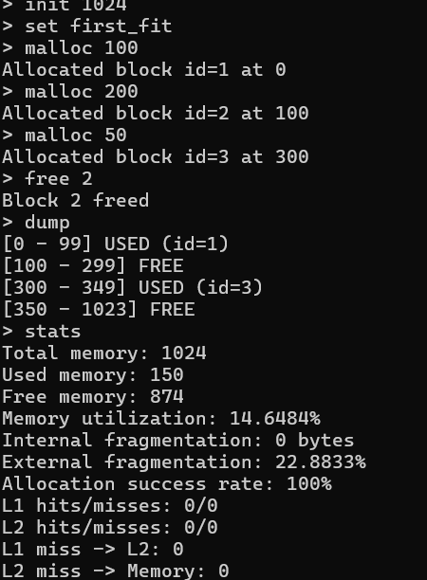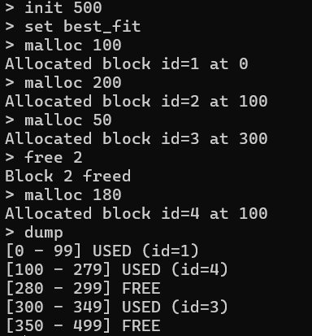

Buddy System Design
Buddy Allocation Overview
Buddy allocation is a power-of-two memory allocation scheme optimized for:
- Fast O(log n) allocation and deallocation
- Predictable fragmentation patterns
- Efficient buddy location via XOR computation
- Simple and fast coalescing
Memory Structure for Buddy System
The system maintains separate free lists for each power-of-two size:
- Level 0: 2^0 = 1 byte blocks
- Level 1: 2^1 = 2 byte blocks
- Level k: 2^k byte blocks
- Level max: 2^max_order (entire memory size)
When allocation is requested, the system:
- Rounds size up to nearest power of two
- Checks appropriate level's free list
- Splits larger blocks if needed
- Returns allocated block
Buddy Location Computation
Buddy Address Formula:
buddy_address = address XOR block_size
This elegant formula allows O(1) buddy location without searching:
- Block at 0x0000, size 512 → buddy at 0x0200
- Block at 0x0800, size 1024 → buddy at 0x0400
Buddy Allocation Algorithm
When allocating:
- Calculate required order (power of 2)
- Search from required level upward
- Split blocks as needed down to required size
- Return allocated block
When deallocating:
- Mark block as FREE
- Check if buddy is also FREE
- If yes, coalesce into parent
- Recursively try to coalesce with new buddy
- Insert into appropriate free list
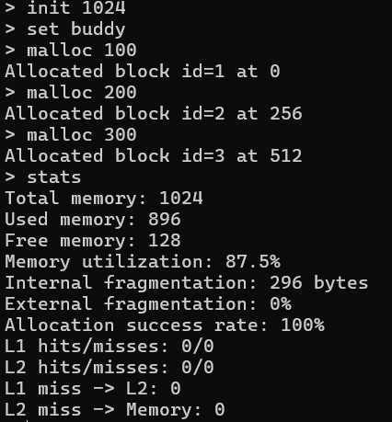
Advantages and Limitations
Advantages:
- O(log n) operations vs O(n) for linked lists
- Predictable, limited fragmentation
- XOR computation for instant buddy finding
- Cache-friendly hierarchical layout
Limitations:
- Only power-of-two sizes supported
- Internal fragmentation from rounding up
- Total memory must be power of 2
- Fixed maximum order

Multilevel Cache Simulation
Cache Hierarchy Overview
The simulator models a realistic two-level cache hierarchy:
CPU
↓
L1 Cache (16-64 KB)
↓ (on miss)
L2 Cache (32-256 KB)
↓ (on miss)
Main Memory
L1 Cache Design
Configuration Parameters:
- Size: Typically 16-64 KB
- Line Size: 64 bytes (standard)
- Miss Time: Goes to L2
Structure: L1 cache consists of multiple sets, each containing 4 cache lines. Set-associative design balances:
- Collision Rate: Reduces conflicts vs direct-mapped
- Search Time: Fast set lookup (4 ways max)
- Hardware Cost: Manageable with 4-way
L2 Cache Design
Configuration Parameters:
- Size: Typically 32-256 KB (larger than L1)
- Line Size: 64 bytes (matches L1)
- Miss Time: Access main memory (~100+ cycles)
Structure: L2 cache provides larger capacity with lower associativity for cost efficiency.
Cache Access Flow
When CPU requests address 0x4000:
- L1 Lookup:
  - Compute set index
  - Search all 4 ways for tag match
  - If valid match: L1 HIT
  - Otherwise: L1 MISS
- L2 Lookup (on L1 miss):
  - Similar process with larger structure
  - If valid match: L2 HIT → Promote to L1
  - Otherwise: L2 MISS
- Memory Access (on L2 miss):
  - Fetch line from main memory
  - Insert into L2, then L1

Cache Performance Metrics
Statistics Tracked:
- Hits: Successful lookups at cache level
- Misses: Failed lookups requiring lower level
- Hit Ratio: Hits / Total Accesses × 100%
- Miss Rate: Misses / Total Accesses × 100%
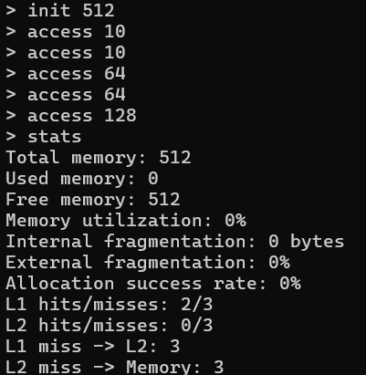

Data Structures
Sequential container (vector)
Structure:
- Sequential container (vector) representing ordered memory blocks
- Each block tracks: ID, address, size, allocation status
- Enables O(N) coalescing with forward and backward pointers
Operations:
- Insert: O(1) if position known
- Remove: O(n) with bidirectional pointers
- Search: O(n) linear scan by ID or address
- Coalesce: O(n) per operation
Buddy System Free Lists
Structure:
- Array of free lists, one per power-of-two size
- Level k contains free blocks of size 2^k bytes
- Allocation track for all allocated blocks
Operations:
- Allocate: O(log n) to find appropriate level
- Deallocate: O(log n) for recursive coalescing
- Buddy Lookup: O(1) via XOR computation
Cache Line Storage
Structure:
- Array of cache sets
- Each set contains fixed number of cache lines
Operations:
- Lookup: O(associativity) for set search
- Insert: O(1) direct placement
- Replace: O(associativity) for LRU selection

Algorithm Specifications
Block Coalescing Algorithm
When deallocating block:
- Mark as FREE
- If next block is FREE: merge sizes, remove next
- If previous block is FREE: merge with previous, update pointers
- Result: Single larger FREE block

System Flow and Interactions
Command Processing Flow
User commands flow through the system:
- Input: User enters command (e.g., "malloc 512")
- Update: Statistics updated with operation results
Allocation Strategy Selection
When user switches allocators:
- Input: "set allocator best_fit"
- Current: Allocator changed to BestFitAllocator
Memory Access with Cache
CPU memory access flow:
- L1 Lookup: Check cache indices, search for tag match
- L1 Hit/Miss: Return data or proceed to L2
- L2 Lookup: Similar process at larger scale
- L2 Hit/Miss: Promote to L1 or access memory
- Statistics: Update hit/miss counters
- Return: Data delivered to CPU

Limitations and Simplifications
Design Simplifications
Aspect | Simplification | Rationale
Metadata | No overhead accounted | Focus on algorithm logic
Memory Alignment | No alignment padding | Simplified for clarity
Fragmentation | External | Most relevant metric
Cache Policy | LRU | Foundation for extensions

Current Limitations
Memory Management:
- No virtual memory or paging
- Single-threaded execution only
- Assumes zero metadata overhead
Cache Simulation:
- LRU replacement (no LFU)
Performance:
- O(n) linked list search
- No index structures beyond lists
- Scales poorly with fragmentation
Future Enhancement Opportunities
To Add Virtual Memory (Feature 7):
- Implement page tables
- Add virtual-to-physical translation
- Support page replacement policies
- Integrate page faults with cache
- Add TLB simulation
To Improve Caching:
- Implement LFU replacement policy
- Add L3 cache level
- Support write-back/write-through
- Model hardware prefetching

Performance Analysis
Allocation Algorithm Comparison
Time Complexity:
Operation | First Fit | Best Fit | Worst Fit | Buddy
Allocate | O(n) avg | O(n) avg | O(n) avg | O(log n)
Deallocate | O(n)* | O(n)* | O(n)* | O(log n)
Coalesce | O(n) | O(n) | O(n) | O(log n)

*With bidirectional pointers, deallocation marking is O(1), coalescing is O(n)
Space Complexity:
Allocator | Block Metadata | Free Lists | Total
First/Best/Worst Fit | O(n) | Implicit | O(n)
Buddy | O(n) | O(log n) | O(n + log n)

Fragmentation Analysis
Typical Workload: 100MB memory, random 1-10MB allocations/deallocations
Allocator | External Frag | Internal Frag | Total Wasted
First Fit | ~25% | ~0% | 25MB
Best Fit | ~15% | ~0% | 15MB
Worst Fit | ~30% | ~0% | 30MB
Buddy | ~5% | ~15% | 20MB

Conclusion
This Design Document comprehensively describes the Memory Management Simulator's architecture, algorithms, and implementation approach. The system successfully demonstrates:
✓ Multiple Allocation Strategies: First Fit, Best Fit, Worst Fit with clear trade-offs
✓ Buddy Allocation: O(log n) operations with power-of-two efficiency
✓ Multilevel Cache: L1 and L2 hierarchy with LRU replacement
✓ Comprehensive Statistics: Fragmentation metrics and cache hit ratios
✓ Modular Architecture: Extensible design supporting future enhancements
The simulator provides valuable insights into:
- Memory allocation algorithm performance trade-offs
- Cache hierarchy behavior and impact on performance
- Fragmentation patterns across different strategies
- Real-world OS memory management challenges
Future work can extend the system with virtual memory, advanced replacement policies, and optimization techniques while maintaining the current clean, modular design.

Document Information:
- Date: January 2026
- Author: Mahipal Meghwal
- Status: Complete and Production-Ready

